Event invite—sample and template
Below is the invitation the Filipino playgroup used for its event, followed by a template that you can easily adapt to make a flyer of your own.
All you need to do is:
- Copy and save the template as a new Word document.
- Click on the text boxes to replace the text.
- Right-click on the picture and select ‘Change picture’ to upload your own image.
- Add any extra information, and paste in your logo at the bottom, if you like.

Invitation: sample
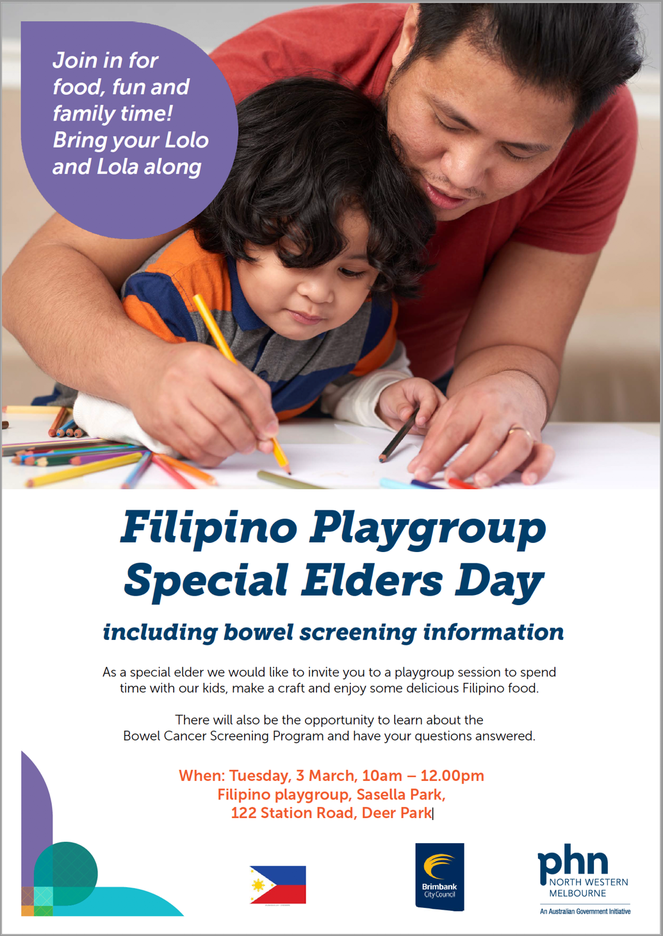

Invitation template: for you to copy, save and adapt
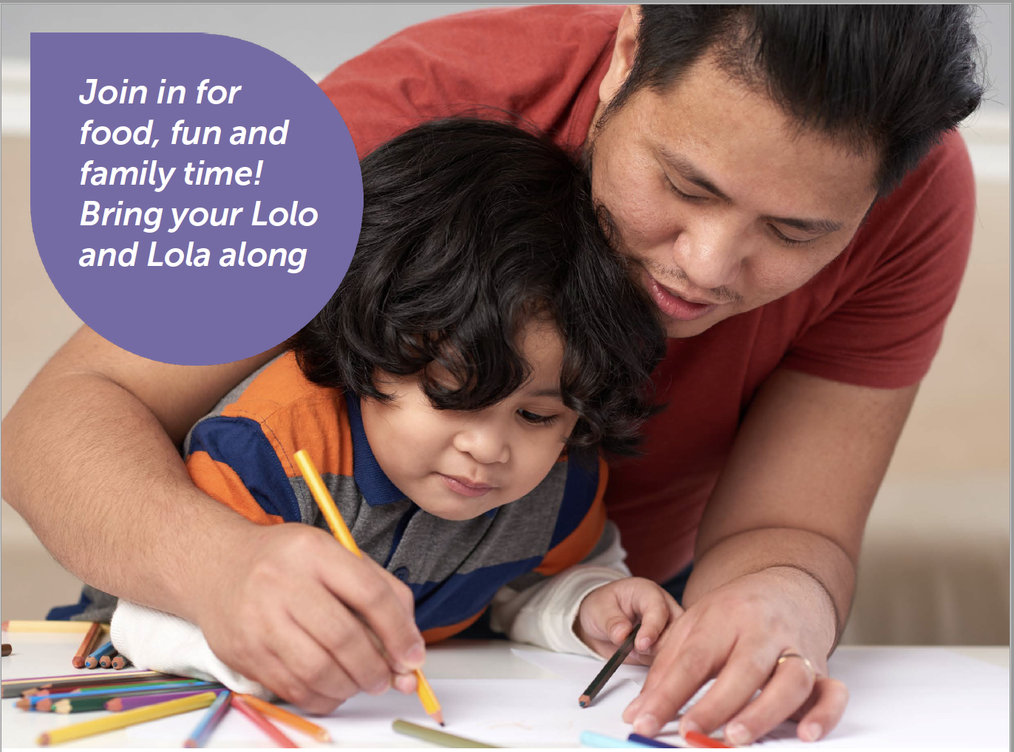
Food, fun and
family time!
Bring your (add your audience) along

and Lola along
Add any other information in this space
Add your logo
Your event name here

including bowel cancer screening information

We would like to invite you to (add what the event is and what will happen)
There will also be an opportunity to learn about the
Bowel Cancer Screening Program and have your questions answered.
Join in for
When: Add a date and time here
Where: Add your address here
Contact: Add a contact person or contact number

