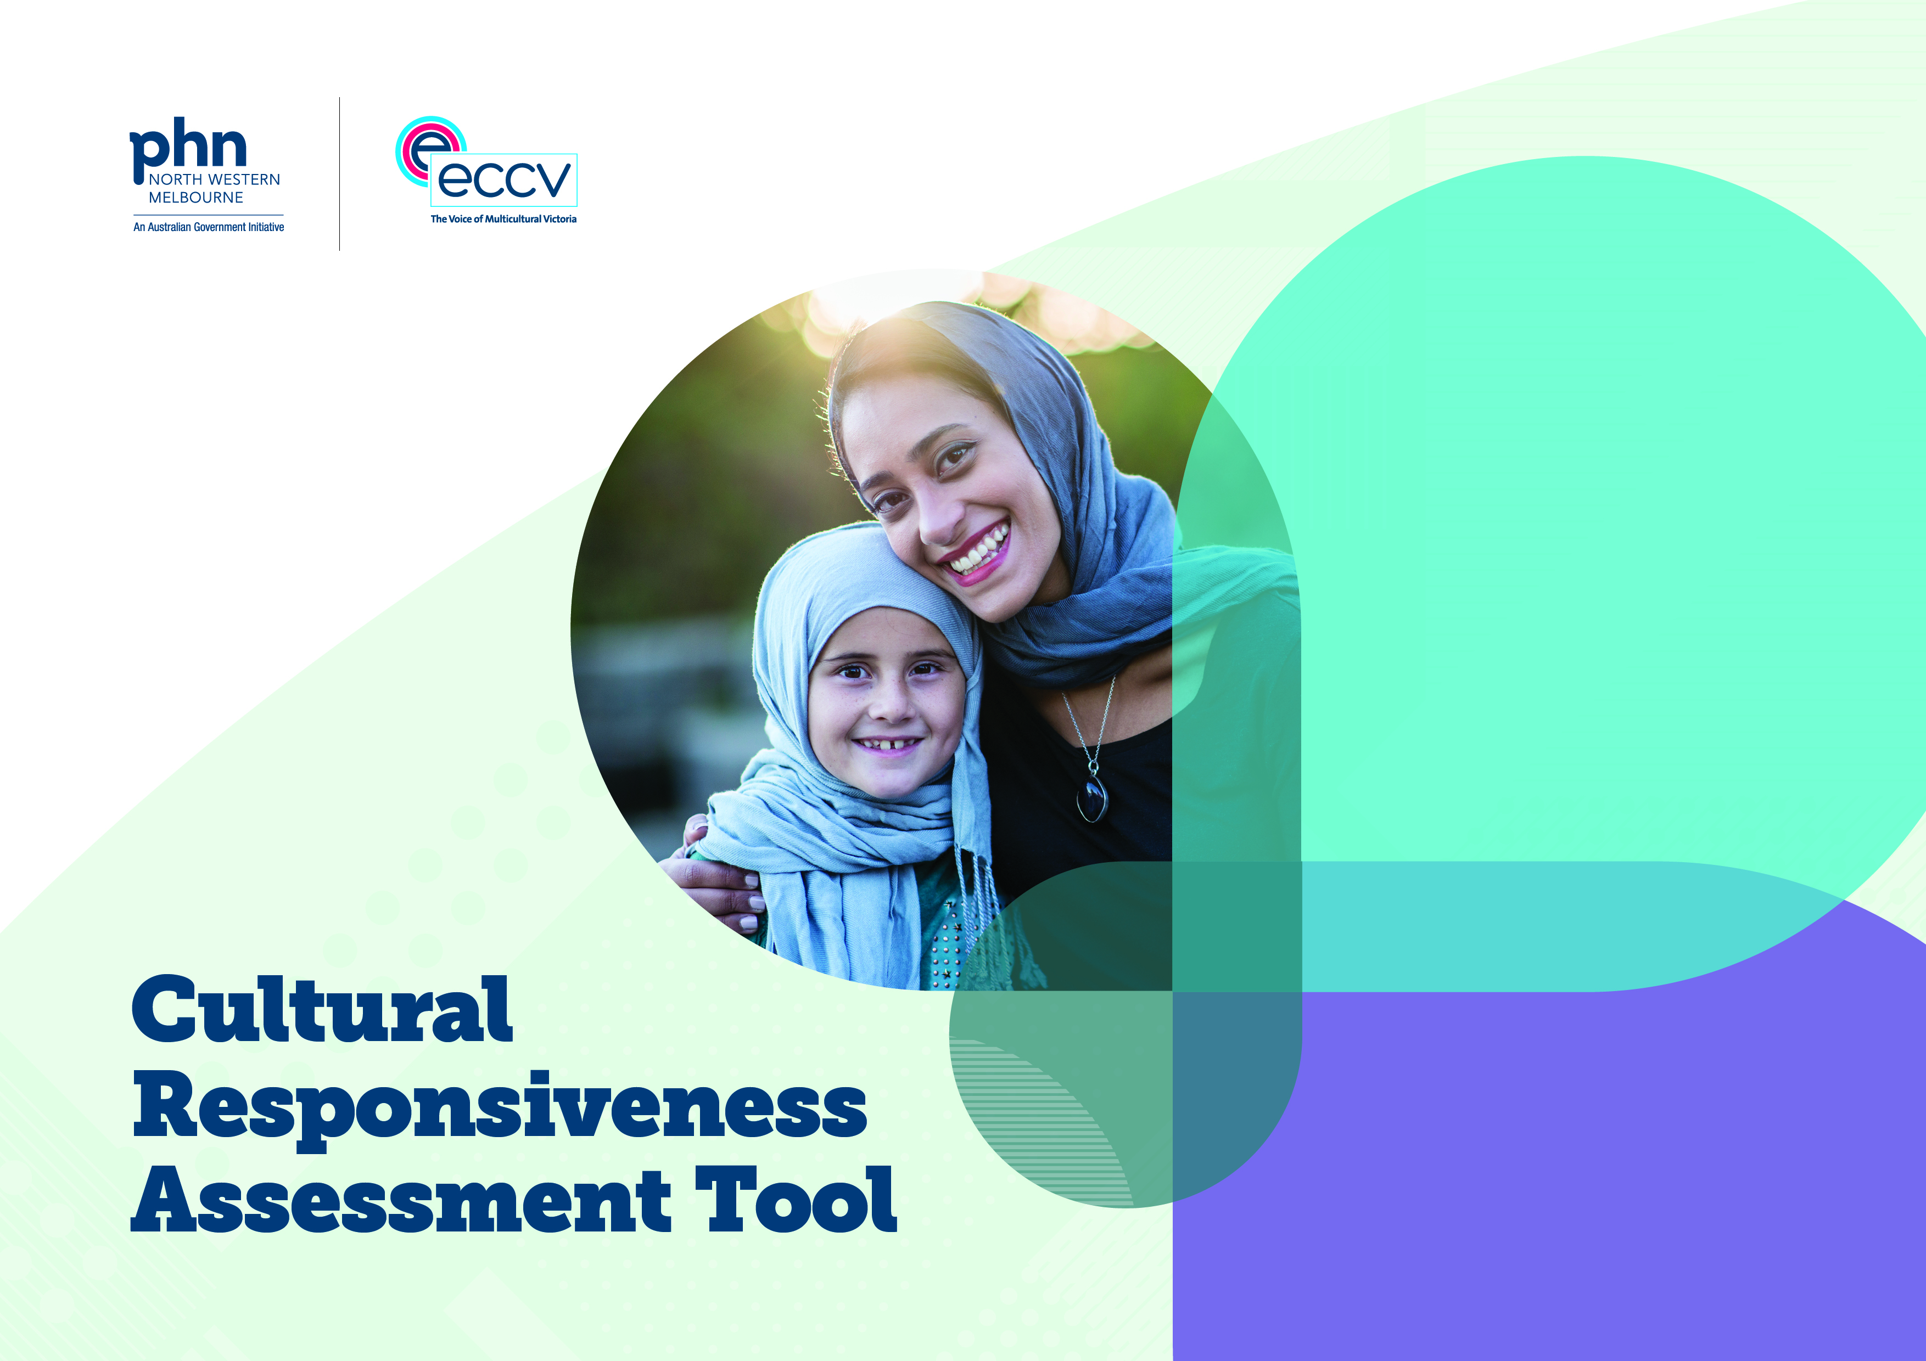

**Name of organisation:**

**Name of service:**

**Date of workshop:** DD/MM/YYYY

**Workshop facilitator:**

**Workshop participants:**

Key to Cultural Responsiveness Assessment Tool

Use the key provided below to complete the Cultural Responsiveness Assessment Tool. Please refer to the [Implementation Guide](https://nwmphn.org.au/resource/cultural-responsiveness-assessment-tool-implementation-guide/) which sets out how to complete this Tool.

What we are currently doing

Write down in this column an activity that you are currently doing at your service that is specifically designed for CALD communities or which is designed to be culturally responsive. If you can’t think of anything, leave the space blank.

Assessing your level of Cultural Responsiveness

Write down your service’s current overall level of cultural responsiveness for the relevant Indicator. Remember to use CALD demographic, service usage data or other CALD health data to inform your self-assessment against each Indicator.

There are 3 levels of cultural responsiveness used to rate a primary care service provider in a particular area or activity. In ascending order, the three levels of cultural responsiveness are: Establishing, Advancing and Excelling. Use the definitions and criteria described to the right and below to assess your current level of cultural responsiveness for each Indicator.

|  |
| --- |
| **Establishing** |
| **Establishing** means that you are aware that cultural responsiveness work needs to be done for a particular Indicator and are exploring options, or have taken the first steps needed to make this happen. Establishing work is the starting point for all further cultural responsiveness improvements you will make. For your service to have achieved an Establishing level for a particular Indicator, you will need to satisfy **at least one** of these criteria:   * You have identified a gap, limitation or area of improvement for cultural responsiveness in your service; * You are currently about to start or have started scoping, researching or consulting on best practice for cultural responsiveness for this Indicator; * You are exploring options or making plans to take action to improve your cultural responsiveness for this Indicator. |
| **Advancing** |
| **Advancing** means that you have made progress in implementing cultural responsiveness into a particular aspect of your service that relates to the Indicator, and are tracking the impact it makes. For your service to have achieved an Advancing level for a particular Indicator, you will need to satisfy **both** of these criteria:   * You are taking action to improve the cultural responsiveness of an aspect of your service that relates to this Indicator; * You have a way to measure the outcome(s) of the Action you are taking to improve your cultural responsiveness for this Indicator. |

|  |
| --- |
| **Excelling** |
| **Excelling** means that you are doing culturally responsive work that can legitimately be called best practice for this Indicator. You will know that this is happening when other services come to you to find out “How did you do it?” For your service to have achieved an Excelling level for a particular Indicator, you will need to satisfy **all** of these criteria:   * The Action has become embedded in the cultural responsiveness of your service so that it is considered “business as usual.” There can be different ways to measure this, which will vary across different types of organisations and service providers. To give some examples, the Action could be a continuing program; it could be the establishment of a dedicated cultural diversity coordinator role; or it could be a commitment to maintaining a workforce with at least 25% of employees from CALD backgrounds. * The Action is subject to a regular evaluation and review process that is part of a quality improvement cycle; * The health outcomes of CALD consumers have been demonstrably improved by this Action. This can be measured in a number of different ways such as improved consumer satisfaction feedback, reduced unnecessary visits or improved clinical outcomes. |

What we can do to improve

Write down in this column what Actions that your service can do to improve its current level of cultural responsiveness. There can be more than one Action for each Indicator, if relevant. These Actions will be used to fill out your Action Plan.

Use SMART goals to help decide on your Actions to input in the Action Plan. SMART stands for Specific, Measurable, Achievable, Realistic and Time-related, as described below:

* **Specific:** Be clear about what you are aiming for. Your Action should include specifics such as “who, where, when, why and what”.
* **Measurable:** Set Actions that you can measure. Your Action should include a quantity such as “number of ___” or “percentage of ___” etc.
* **Achievable:** Set Actions that are actually achievable for your service or organisation.
* **Realistic:** Set Actions that are relevant and make sense for the type of work that your service or organisation provides.
* **Time-related:** Set a timeframe and have a deadline by when you want the Action to be completed.

How we will know we have achieved this

Write down the outcome of the action, that once reached will complete this Action. For example, this can be a measurement, such as a target number of clients using interpreters per month, or when a particular task is completed, such a translations link is added to your website.

Effort

Write down the level of Effort needed for your service to undertake the Action(s) you identified in the “What we can do to improve” column. Choose from Low, Medium or High.

Impact

Write down the level of Impact that the Action(s) will make to your service’s cultural responsiveness if the Action(s) are implemented. Choose from Low, Medium or High.

Priority

Based on the Effort and Impact levels that you identified for the Action(s), write down an overall Priority level for the Action(s), choosing again from Low, Medium and High.

Cultural Responsiveness Assessment Tool

| Activity area | Indicator | What we are currently doing | Level of Cultural Responsiveness (Establishing, Advancing or Excelling) | What we can do to improve (Action) | How we will know we have achieved this (Measurement) | Effort | Impact | Priority |
| --- | --- | --- | --- | --- | --- | --- | --- | --- |
| **Participation and engagement** | **1. Co-production with community** |  |  |  |  |  |  |  |
|  | **2. Workforce mutuality** |  |  |  |  |  |  |  |
|  | **3. Consumer feedback** | ­ |  | ­ |  |  |  |  |
| **Access and equity** | **4. Culturally responsive digital access** |  |  |  |  |  |  |  |
|  | **5. Interpreter Engagement** |  |  |  |  |  |  |  |
|  | **6. Culturally responsive communications** |  |  |  |  |  |  |  |
|  | **7. Culturally responsive referrals and partnerships** |  |  |  |  |  |  |  |
| **Culture and capacity** | **8. Culturally responsive leadership and organisational culture** |  |  |  |  |  |  |  |
|  | **9. Culturally responsive data** |  |  |  |  |  |  |  |
|  | **10. Cultural responsiveness training** |  |  |  |  |  |  |  |

Notes