Walrus Installation Step-by-Step Guide
To start using Walrus client, follow the steps below:
Step 1: Download the Walrus client installer from https://polarexplorer.org.au/Downloads/WalrusClient/setup.exe
Step 2: Run the installer application, setup.exe
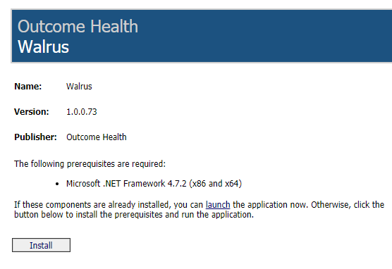
Step 3: When Walrus starts you will be asked to enter your POLAR username and password.

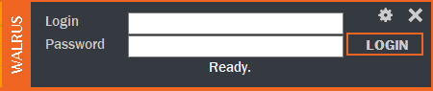

POLAR Walrus Video - https://youtu.be/lLNWNl4j8dc

